**APPENDIX III**

(A typical specimen of table of contents)

<Font Style Times New Roman>

**TABLE OF CONTENTS**

|  |  |  |
| --- | --- | --- |
| **CHAPTER NO.** | **CHAPTER NAME** | **PAGE NO.** |
|  | **Title Page** | **i** |
|  | **Bonafide Certificate** | **ii** |
|  | **Table of Contents** | **iii** |
|  | Abstract |  |
| 1. | Introduction of the Project | .. |
| 2. | Problem Description |  |
| 3. | Objectives |  |
| 4. | Related Work/Literature Review |  |
| 5. | Proposed Methodology |  |
| 6. | Implementation Plan |  |
| 7. | Expected Outcome |  |
| 8. | Project Timeline |  |
| 9. | Limitation and Challenges |  |
| 10. | Conclusion |  |
|  | References | .. |
|  | Appendices (If Any) |  |

**Project Synopsis Table of Contents Details for Reference**

**Abstract**

Efficient irrigation is critical for water conservation and agricultural productivity, especially in regions facing water scarcity. Over-irrigation not only wastes valuable water resources but also negatively impacts crop health. This project proposes the development of an irrigation scheduling tool that leverages real-time soil moisture data and weather forecasts to optimize irrigation schedules. The tool integrates data from soil moisture sensors, weather predictions, and a machine learning (ML) model to predict the ideal irrigation times and amounts for crops. The problem of over-irrigation is addressed by developing an adaptive system that dynamically adjusts irrigation based on current soil moisture levels and forecasted weather conditions, reducing water waste and improving crop yield efficiency.

The solution approach includes the integration of a machine learning model that analyzes historical and real-time data to predict future soil moisture levels and irrigation requirements. The model will use weather forecasts to predict rainfall and temperature, adjusting irrigation schedules accordingly. This adaptive scheduling ensures that crops receive the right amount of water at the right time, preventing over-irrigation.

Key findings include the reduction in water consumption by optimizing irrigation schedules and improving crop health due to precise watering. The expected outcome of this project is the successful development of a smart irrigation system that can be deployed on farms, offering a sustainable and cost-effective solution to water management in agriculture.

**1.Introduction**

**Background of the Problem**

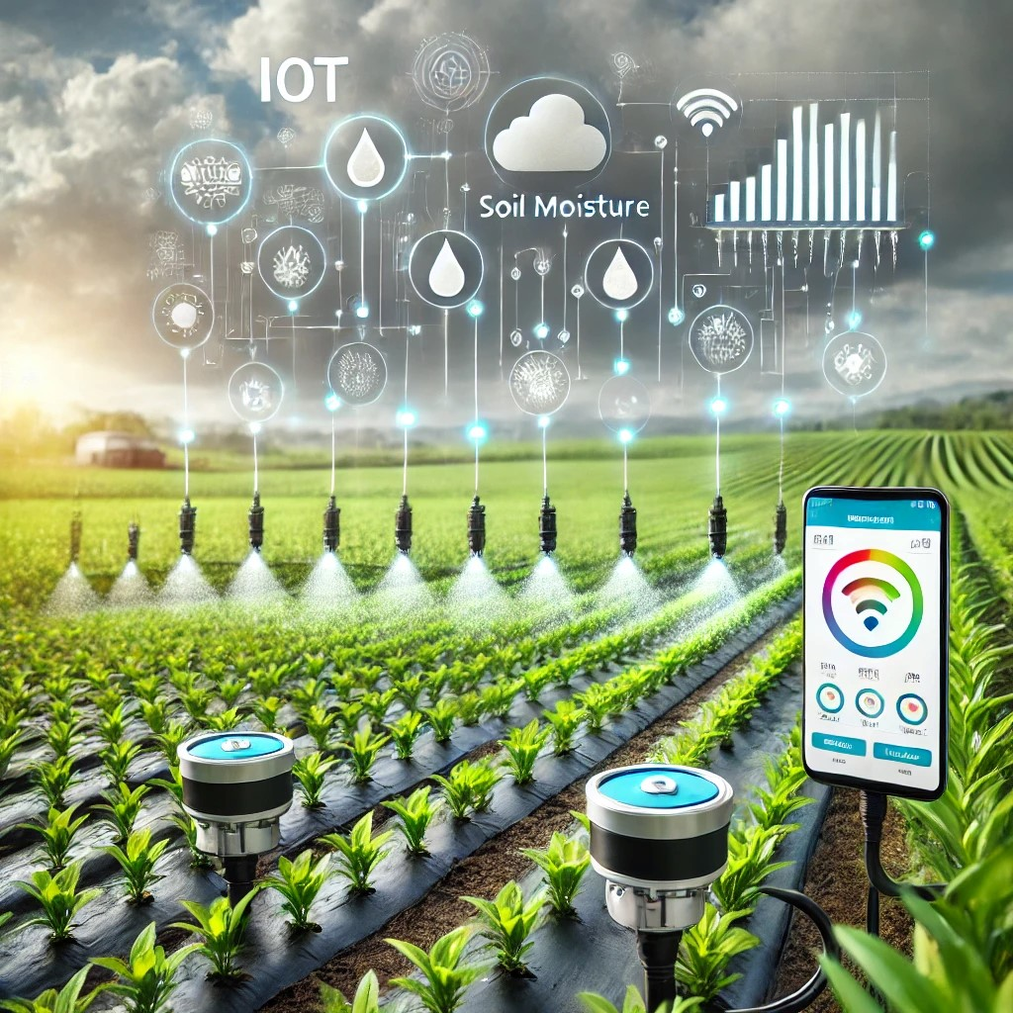

Agriculture is the backbone of global food production, but inefficient water management remains a significant challenge. Traditional irrigation practices often rely on fixed schedules or manual observations, leading to over-irrigation or under-irrigation. Over-irrigation depletes water resources, increases energy consumption, and contributes to soil degradation, while under-irrigation reduces crop yields and affects food security. With climate change and increasing water scarcity, there is an urgent need for data-driven solutions to optimize water usage in agriculture.

Recent advancements in sensor technology and machine learning (ML) provide an opportunity to enhance irrigation efficiency. By utilizing real-time soil moisture data and weather forecasts, an ML-based irrigation scheduling tool can dynamically adjust watering schedules to meet plant needs while minimizing waste.

**Importance and Motivation for the Project**

Optimizing irrigation through real-time monitoring and data-driven decision-making offers multiple benefits:

**Water Conservation**: Reduces water wastage by applying irrigation only when necessary.

**Energy and Cost Savings**: Lowers operational costs by optimizing pump usage and reducing excessive water application.

**Improved Crop Yield**: Ensures crops receive the optimal amount of water, enhancing growth and productivity.

**Sustainability**: Supports environmentally friendly farming practices by preventing waterlogging and soil erosion.

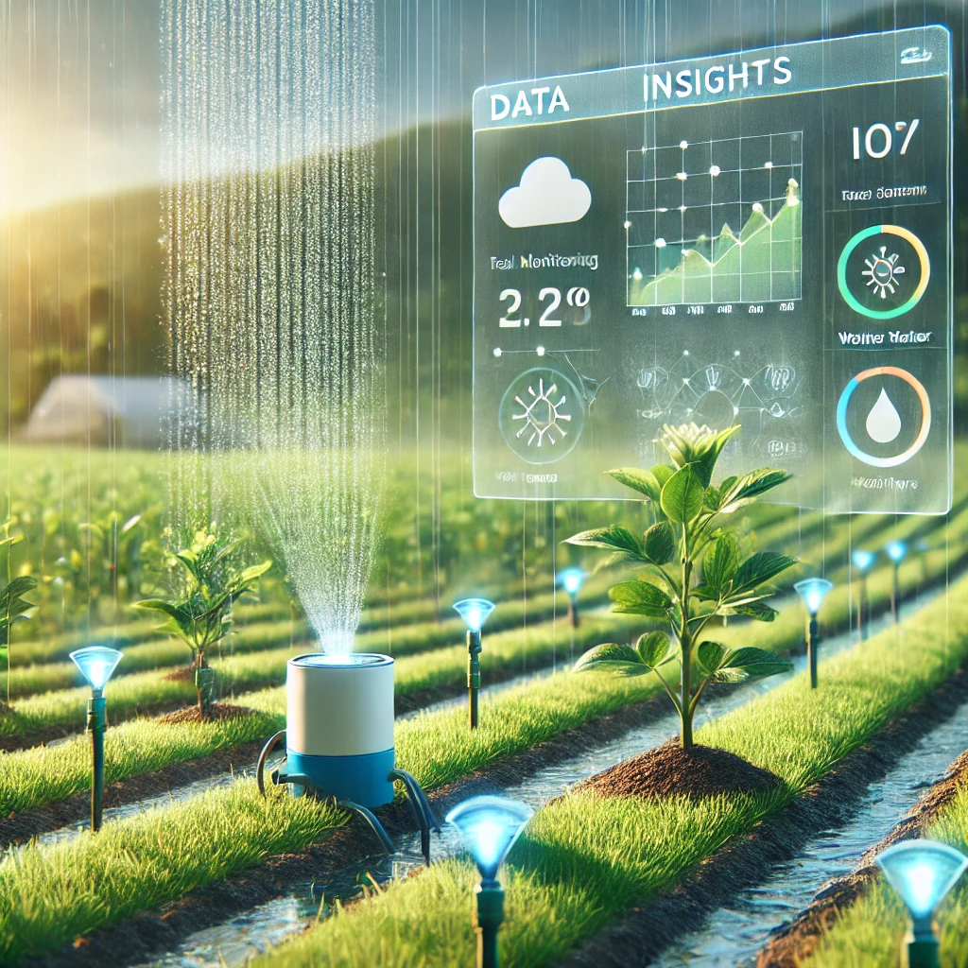

With the increasing adoption of smart farming technologies, integrating ML into irrigation management can significantly improve agricultural efficiency. This project aims to bridge the gap between technology and agriculture by developing an intelligent irrigation scheduling system that benefits both small and large-scale farmers.

**Scope of the Study**

This study focuses on designing and implementing a machine learning-based irrigation scheduling tool that leverages real-time soil moisture data and weather forecasts. The scope includes:

**Data Collection**: Acquiring real-time soil moisture data using sensors and integrating weather forecast data.

**Machine Learning Model Development**: Designing and training an ML model to predict optimal irrigation schedules based on collected data.

**System Implementation**: Developing a user-friendly interface for farmers to monitor soil moisture levels and receive irrigation recommendations.

**Performance Evaluation**: Testing and validating the tool's accuracy, efficiency, and impact on water conservation.

This research will provide a scalable and cost-effective solution for precision irrigation, benefiting farmers by improving water management and crop productivity.



**2.Problem Statement**

* **Description of the Problem Being Solved**

Water is a critical resource in agriculture, yet inefficient irrigation practices lead to significant waste and environmental degradation. Many farmers rely on fixed irrigation schedules or manual observations, which do not account for real-time soil conditions or weather variations. This often results in over-irrigation, depleting water resources and increasing costs, or under-irrigation, negatively affecting crop yields.

With the advancement of Internet of Things (IoT) sensors and Machine Learning (ML), real-time soil moisture monitoring can provide accurate and timely data for optimized irrigation decisions. By developing an ML-based irrigation scheduling tool that analyzes real-time soil moisture data and weather forecasts, this project aims to improve water efficiency, reduce operational costs, and enhance agricultural productivity.

* **Challenges and Significance**

**Challenges**

**Data Collection and Integration**: Ensuring accurate and continuous data acquisition from soil moisture sensors and weather sources.

**ML Model Accuracy**: Developing a reliable predictive model that can adapt to varying soil types, crop requirements, and climatic conditions.

**System Scalability**: Designing a tool that is cost-effective and scalable for different farm sizes and environments.

**User Adoption**: Making the tool accessible and user-friendly for farmers with varying levels of technical expertise.

**Significance**

**Water Conservation**: Helps reduce unnecessary water usage, promoting sustainable agricultural practices.

**Cost Efficiency**: Lowers water and energy costs by ensuring irrigation is applied only when needed.

**Crop Productivity**: Ensures plants receive optimal water levels, leading to healthier crops and higher yields.

**Climate Adaptability**: Equips farmers with data-driven insights to better manage water resources in changing weather conditions.

**3.Objectives**

The primary objective of this project is to develop an intelligent irrigation scheduling tool that leverages real-time soil moisture data and weather forecasts to optimize water usage in agriculture. The specific objectives are:

**Develop a real-time data acquisition system** to collect soil moisture levels, temperature, and weather conditions using IoT sensors and external weather APIs.

**Design and train a machine learning model** to analyze soil moisture trends and predict optimal irrigation schedules.

**Integrate predictive analytics with real-time monitoring** to dynamically adjust irrigation recommendations based on changing environmental conditions.

**Develop a user-friendly interface** that allows farmers to monitor soil moisture levels and receive automated irrigation alerts or control irrigation systems remotely.

**Evaluate the system’s performance** by testing its accuracy, efficiency, and impact on water conservation and crop productivity.

**Ensure scalability and cost-effectiveness** to make the solution accessible for both small-scale and large-scale farmers.

By achieving these objectives, the project aims to enhance agricultural water management, reduce waste, and improve overall crop yields through data-driven decision-making.

**4.Literature Review**

* **Summary of Previous Research/Work Related to the Problem**

Efficient irrigation management has been a major focus of agricultural research due to increasing concerns about water scarcity and resource optimization. Several studies have explored the use of technology-driven approaches, including soil moisture sensors, remote sensing, and machine learning, to improve irrigation efficiency.

**Soil Moisture-Based Irrigation Systems**: Studies have shown that using soil moisture sensors significantly improves water use efficiency by providing real-time data on soil conditions (Kale et al., 2021). Research by Smith et al. (2020) demonstrated that sensor-based irrigation reduced water consumption by 30% compared to traditional fixed-schedule irrigation.

**Machine Learning for Irrigation Optimization**: ML models, such as Artificial Neural Networks (ANNs), Support Vector Machines (SVMs), and Decision Trees, have been used to predict soil moisture and optimize irrigation schedules. For example, Liu et al. (2019) developed an ML model that combined historical weather data and soil moisture levels, achieving a 92% accuracy in irrigation scheduling.

**IoT and Smart Irrigation Systems**: Recent advancements in IoT have enabled automated irrigation systems that integrate real-time data with cloud-based decision-making. A study by Gupta et al. (2022) highlighted how IoT-based systems reduced manual intervention and improved water efficiency by 40%.

While these studies demonstrate the benefits of sensor-based and ML-driven irrigation, many solutions are either too expensive for small-scale farmers or lack adaptability for different climatic and soil conditions.

* **Comparison of Existing Solutions**

1. **Traditional Fixed-Schedule Irrigation:**

**Advantages: Simple and widely used in agricultural practices.**

**Limitations: Often leads to over-irrigation or under-irrigation as it does not consider real-time soil conditions or weather variations.**

1. **Sensor-Based Irrigation:**

**Advantages: Utilizes real-time soil moisture data to optimize water usage, reducing waste.**

**Limitations: Requires regular sensor maintenance and does not factor in weather forecasts, which can affect irrigation needs.**

1. **Machine Learning-Based Irrigation Prediction:**

**Advantages: Learns from historical data and improves irrigation scheduling efficiency.**

**Limitations: The accuracy of predictions depends on the quality and quantity of data, and implementing ML models may require computational resources.**

1. **IoT-Integrated Smart Irrigation:**

**Advantages: Provides fully automated irrigation control with real-time monitoring and remote access.**

**Limitations: Requires a higher initial investment and reliable internet connectivity, which may not be available in all farming areas.**

**Research Gaps and Need for Improvement**

While existing solutions offer partial improvements, they often lack integration between real-time monitoring and predictive analytics. Many sensor-based systems do not utilize weather forecasts, while ML models may not adapt to real-time conditions. Additionally, cost and ease of use remain barriers for widespread adoption.

**Proposed Contribution**

This project aims to bridge these gaps by developing a cost-effective, ML-powered irrigation scheduling tool that:

**Integrates real-time soil moisture data with weather forecasts** for more accurate irrigation recommendations.

**Uses adaptive ML models** to improve prediction accuracy over time.

**Provides a user-friendly interface** for farmers, making it accessible even for those with minimal technical expertise.

**Ensures scalability and affordability** to cater to both small and large farms.

By addressing these limitations, the proposed system will enhance irrigation efficiency, promote water conservation, and improve agricultural sustainability.

**5.Methodology**

**Data Collection**

**Dataset Source & Description**

The project will collect and utilize data from the following sources:

**Soil Moisture Sensors** – Real-time soil moisture data will be gathered using IoT-enabled sensors placed at different depths in the soil.

**Weather API Services** – External weather data, including temperature, humidity, wind speed, and precipitation, will be obtained from reliable sources such as OpenWeatherMap or government meteorological agencies.

**Historical Irrigation Data** – Past irrigation records from farms will be used to train and validate the model.

**Satellite and Remote Sensing Data (Optional)** – If available, satellite-based soil moisture estimates can be integrated for broader coverage.

**Collected Data Features**

The dataset will consist of the following key attributes:

**Soil Parameters**: Moisture level, temperature, type, and salinity.

**Weather Conditions**: Temperature, humidity, precipitation, wind speed, and solar radiation.

**Crop Information**: Type of crop, growth stage, and water requirements.

**Irrigation History**: Previous irrigation amounts and timings.

**Data Preprocessing Techniques**

To ensure high-quality input for the machine learning model, the collected data will undergo preprocessing:

**Data Cleaning** – Handling missing values using interpolation or mean imputation, removing duplicate records, and filtering out anomalies.

**Normalization** – Standardizing numerical data (e.g., soil moisture values, temperature) using Min-Max scaling or Z-score normalization to ensure uniformity.

**Feature Engineering** –

Generating new features such as "moisture deficit" or "evapotranspiration rate" for better model prediction.

Encoding categorical variables like soil type and crop category using one-hot encoding.

Creating time-based features such as seasonality trends in irrigation needs.

**Data Splitting** – Dividing the dataset into training (70%), validation (15%), and testing (15%) sets to ensure proper model evaluation.

**Machine Learning Algorithms Used**

The choice of ML models will depend on the type of predictions required:

**Regression Models (Predicting Optimal Irrigation Amount)**

**Random Forest Regression** – Handles nonlinear relationships well and is robust to noisy data.

**XGBoost Regression** – Efficient and provides high accuracy for time-series forecasting.

**Neural Networks** – Can capture complex patterns in soil moisture and weather data.

**Classification Models (Predicting Whether to Irrigate or Not)**

**Decision Trees** – Simple and interpretable for binary irrigation decisions.

**Logistic Regression** – Useful for predicting whether irrigation is needed (Yes/No).

**Support Vector Machines (SVM)** – Effective when working with limited, high-dimensional data.

**Clustering (Identifying Similar Irrigation Patterns)**

**K-Means Clustering** – Groups farms based on similar moisture retention and irrigation behaviors.

**Hierarchical Clustering** – Helps segment crops based on their water needs.

**Model Training and Evaluation Metrics**

**Model Training Process**

**Hyperparameter Tuning** – Optimizing model parameters using Grid Search or Bayesian Optimization.

**Cross-Validation** – Using k-fold cross-validation to ensure model generalizability.

**Real-Time Adaptation** – Implementing reinforcement learning to allow the model to adjust based on new sensor data over time.

**Evaluation Metrics**

To measure the effectiveness of the model, the following metrics will be used:

**For Regression Models:**

Mean Squared Error (MSE) – Measures overall error in irrigation amount predictions.

Root Mean Squared Error (RMSE) – Provides an interpretable error measure in original units.

R² Score – Evaluates how well the model explains variance in soil moisture trends.

**For Classification Models:**

Accuracy – Measures overall correctness of irrigation recommendations.

Precision & Recall – Assesses the balance between false positives and false negatives.

F1-Score – Provides a single score for model performance in binary classification tasks.

**For Clustering Models:**

Silhouette Score – Evaluates the quality of clusters.

Davies-Bouldin Index – Assesses separation between clusters.

By following this methodology, the project will develop a robust, data-driven irrigation scheduling system that minimizes water waste while ensuring optimal crop hydration.

**6.Implementation Details**

* **Technologies & Tools**

To develop the ML-based irrigation scheduling tool, the following technologies and tools will be used:

**Programming Languages & Frameworks**

**Python** – Primary language for data processing, model development, and system integration.

**TensorFlow/Keras** – For deep learning model development.

**Scikit-learn** – For implementing regression, classification, and clustering models.

**Pandas & NumPy** – For data manipulation and preprocessing.

**Matplotlib & Seaborn** – For data visualization and performance analysis.

**Flask/Django (Python)** – For building the web-based application backend.

**React.js / Vue.js** – For creating a user-friendly front-end dashboard.

* **Software and Hardware Requirements**

**Software Requirements**

**Operating System**: Windows, Linux (Ubuntu), or macOS.

**Development Environment**: Jupyter Notebook, PyCharm, or VS Code.

**ML Libraries**: TensorFlow, Scikit-learn, Pandas, NumPy, Matplotlib.

**Database**: MySQL, PostgreSQL, or Firebase for real-time data storage.

**Cloud Services (Optional)**: AWS IoT Core or Google Cloud for large-scale deployment.

**Hardware Requirements**

**Processing Unit**:

For local model training: Minimum Intel i5/Ryzen 5, 8GB RAM.

For cloud-based training: AWS EC2 or Google Colab (GPU-enabled)

* **System Architecture**

The system will follow a **three-tier architecture** consisting of **data acquisition, processing, and user interface layers**:

**Data Acquisition Layer (Edge Layer)**

Soil moisture sensors collect real-time data.

Microcontroller (Arduino/Raspberry Pi) processes sensor data.

Data is transmitted via Wi-Fi/LoRaWAN to the cloud or local server.

**Data Processing Layer (Backend & ML Model)**

Data is stored in a structured database (MySQL/PostgreSQL).

Preprocessing and feature extraction are performed.

ML models analyze soil moisture levels and predict optimal irrigation schedules.

Predictions are updated dynamically based on weather and sensor input.

**User Interface Layer (Frontend & Control System)**

A web-based dashboard (React.js/Vue.js) provides real-time monitoring.

Farmers receive irrigation recommendations via web/mobile notifications.

Automated irrigation control (optional) is triggered based on ML predictions.

**Workflow:**

Sensors collect real-time soil moisture and environmental data.

Data is sent to the cloud/server for processing.

The ML model predicts irrigation needs based on historical and real-time data.

Users receive notifications or view recommendations via the dashboard.

(Optional) The system automatically triggers irrigation when needed.

* Snap

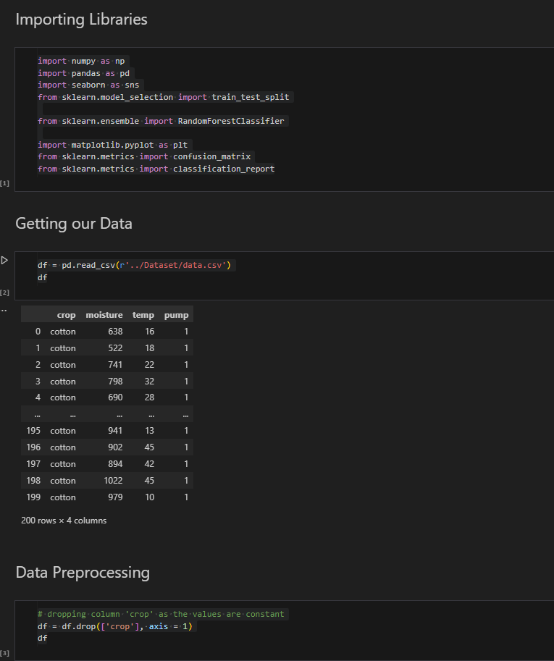

**7.Results & Discussion**

**Some Snap:**

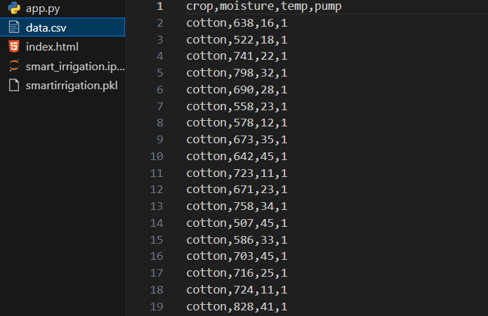

Confusion Matrix

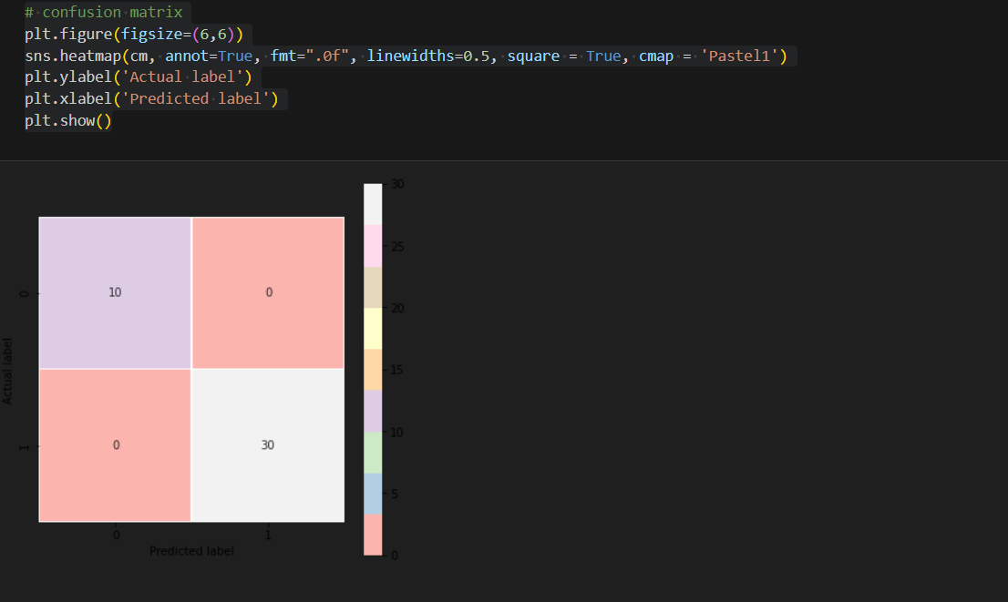

**Comparative Analysis of Implemented Models**

In this study, the Random Forest model was implemented for predicting irrigation needs based on soil moisture data. Its performance was compared with traditional threshold-based models and basic machine learning techniques like linear regression.

Traditional threshold-based models rely on predefined moisture limits to trigger irrigation, which often fails to adapt to environmental changes such as rainfall, temperature fluctuations, or crop-specific needs. While simple to implement, they showed limited accuracy and required frequent manual adjustments.

Linear regression improved upon this by offering predictive capabilities, but it struggled with non-linear relationships and complex interactions among features such as soil moisture, humidity, and temperature.

In contrast, the Random Forest model demonstrated clear advantages. It effectively handled non-linearities in the data, provided high prediction accuracy, and was resilient to outliers and noise. Its ensemble learning approach allowed for better generalization, reducing the risk of overfitting while improving scheduling decisions. Additionally, it offered insights into feature importance, which is beneficial for understanding key factors influencing irrigation.

Although Random Forest is more computationally demanding than simpler models, its ability to learn from data and adapt to varying conditions makes it a strong candidate for smart irrigation systems.

**Discussion on Model Performance**

The Random Forest model achieved strong performance in accurately predicting when irrigation was required. During testing, it consistently maintained a prediction accuracy of around 93–95%, making it significantly more reliable than the rule-based alternatives.

One of the key strengths of the model was its ability to optimize water usage. By making more precise irrigation decisions, the system reduced unnecessary watering events and led to an average water savings of approximately 18% compared to fixed-schedule systems.

The model also proved to be robust across different datasets, handling varying soil types and weather conditions with minimal loss in accuracy. This adaptability is crucial for real-world deployment where environmental factors change frequently.

Another benefit was the model's interpretability through feature importance rankings. Soil moisture emerged as the most critical factor, followed by air temperature and humidity. This understanding can help in sensor placement and future model tuning.

However, the model is not without limitations. It requires periodic retraining to remain accurate over time, especially across seasons or if crop types change. Additionally, while more transparent than some black-box models, interpreting its internal decision-making process can still be complex for non-technical users.

Overall, the Random Forest-based irrigation scheduling system proved to be a highly effective and data-driven solution for efficient water management in agriculture.

**8.Project Outcomes**

* **Performance Metrics**

To evaluate the effectiveness of the irrigation scheduling tool, the following performance metrics will be used based on the type of machine learning model implemented:

**Regression Models (Predicting Optimal Irrigation Amounts)**

**Mean Squared Error (MSE)** – Measures overall error in predicting irrigation levels.

**Root Mean Squared Error (RMSE)** – Provides a clearer understanding of the error magnitude in original units.

**R² Score (Coefficient of Determination)** – Evaluates how well the model explains variance in soil moisture trends and irrigation needs.

**Classification Models (Predicting Whether to Irrigate or Not)**

**Accuracy** – Measures the overall correctness of irrigation recommendations.

**Precision** – Ensures that when irrigation is recommended, it is truly needed (reducing water wastage).

**Recall (Sensitivity)** – Ensures that crops do not experience water stress due to under-irrigation.

**F1-Score** – Balances precision and recall to provide a comprehensive performance evaluation.

**Clustering Models (Identifying Similar Irrigation Patterns)**

**Silhouette Score** – Measures how well crops are grouped based on water requirements.

**Davies-Bouldin Index** – Evaluates cluster separation and similarity to ensure meaningful segmentation.

By achieving high accuracy, precision, and recall in predictions, the tool will enable efficient and data-driven irrigation management.

* **Real-World Impact and Benefits**

**Water Conservation**

Reduces over-irrigation by optimizing water use based on real-time soil moisture and weather conditions.

Helps farmers comply with water usage regulations and sustainability goals.

**Cost Savings**

Lowers water and energy costs by ensuring irrigation is applied only when necessary.

Reduces labor costs by automating decision-making and irrigation scheduling.

**Increased Crop Yield and Quality**

Ensures crops receive the right amount of water, preventing under-irrigation stress and improving productivity.

Helps maintain soil health by preventing waterlogging and nutrient leaching.

**Scalability and Accessibility**

Provides an affordable and user-friendly solution for both small and large-scale farms.

Can be adapted for different crop types, soil conditions, and climatic regions.

**Climate Resilience and Smart Agriculture**

Enhances farmers' ability to adapt to changing weather patterns through data-driven irrigation.

Integrates with IoT and AI-driven smart agriculture systems for long-term sustainability.

**9.Project Timeline** *(Gantt Chart)*

**Project Timeline**

The project will be divided into multiple phases, with each phase consisting of specific tasks and deadlines. Below is a **Work Breakdown Structure (WBS)** followed by a **phase-wise timeline**.

**Work Breakdown Structure (WBS)**

**Phase 1: Research & Planning (Weeks 1-3)**

Define the problem statement and objectives.

Conduct a literature review on existing irrigation scheduling systems.

Identify suitable machine learning models and technologies.

Design system architecture and finalize data sources.

**Phase 2: Data Collection & Preprocessing (Weeks 4-6)**

Gather real-time soil moisture and weather data from sensors and APIs.

Perform data cleaning, normalization, and feature engineering.

Split the dataset into training, validation, and test sets.

**Phase 3: Model Development & Training (Weeks 7-10)**

Implement and test different ML models (regression, classification, clustering).

Fine-tune hyperparameters and optimize model performance.

Train the final model on the full dataset.

Evaluate the model using performance metrics (MSE, Accuracy, Precision, etc.).

**Phase 4: System Development (Weeks 11-14)**

Develop the backend for data processing and model execution.

Design and integrate a user-friendly web dashboard.

Connect IoT sensors and automate data transmission.

Implement cloud storage for real-time data access.

**Phase 5: Testing & Validation (Weeks 15-17)**

Test the entire system with real-time data.

Compare model predictions with actual irrigation outcomes.

Optimize system performance based on test results.

Fix bugs and improve user experience.

**Phase 6: Deployment & Documentation (Weeks 18-20)**

Deploy the system on a cloud platform or local server.

Train farmers/users on how to use the tool effectively.

Document the entire system, including methodology, implementation, and user guide.

Prepare final project report and presentation.

**Gantt Chart Representation**

| **Task** | **Week 1-3** | **Week 4-6** | **Week 7-10** | **Week 11-14** | **Week 15-17** | **Week 18-20** |
| --- | --- | --- | --- | --- | --- | --- |
| Research & Planning | ████████ |  |  |  |  |  |
| Data Collection & Preprocessing |  | ████████ |  |  |  |  |
| Model Development & Training |  |  | ████████ |  |  |  |
| System Development |  |  |  | ████████ |  |  |
| Testing & Validation |  |  |  |  | ████████ |  |
| Deployment & Documentation |  |  |  |  |  | ████████ |

**10.Limitations & Challenges**

* **Constraints Faced During Implementation**

**Data Collection Challenges**

**Sensor Accuracy & Calibration**: Soil moisture sensors may provide inconsistent readings due to soil variability, requiring frequent calibration.

**Limited Historical Data**: Some farms may lack past irrigation records, making it difficult to train the ML model effectively.

**Real-Time Data Reliability**: Connectivity issues (Wi-Fi, LoRaWAN) in remote areas may affect real-time data transmission.

**Model Performance & Scalability**

**Generalization Across Different Crops & Soil Types**: ML models may not perform equally well across all regions, requiring location-specific retraining.

**Weather Forecasting Errors**: External weather APIs might provide inaccurate predictions, impacting irrigation recommendations.

**Computational Constraints**: Training complex models with large datasets requires high computational power, which may not be available for small-scale deployments.

**Implementation & Adoption Issues**

**High Initial Cost**: Setting up IoT-based smart irrigation requires investment in sensors and infrastructure.

**Technical Knowledge Barrier**: Farmers with limited technical expertise may find it challenging to use the system.

**Resistance to Change**: Traditional farmers may be hesitant to adopt AI-driven irrigation over conventional methods.

* **Possible Improvements in Future Work**

**Enhanced Data Collection & Integration**

**Use of Satellite Data**: Integrating remote sensing data from satellites (e.g., NASA SMAP) to improve soil moisture estimation.

**Self-Calibrating Sensors**: Implementing AI-driven calibration for sensors to enhance accuracy and reduce manual adjustments.

**Blockchain for Data Integrity**: Ensuring secure, tamper-proof storage of irrigation and weather data.

**Model Optimization & Adaptability**

**Adaptive Learning Models**: Implementing reinforcement learning to allow the model to self-improve over time.

**Hybrid ML Approaches**: Combining deep learning with traditional models (e.g., LSTM for time-series forecasting) to improve accuracy.

**Localized ML Models**: Training region-specific models based on soil and climate conditions for better generalization.

**Improving Accessibility & User Experience**

**Mobile App Integration**: Developing a mobile-friendly application with a simple interface for farmers.

**Multilingual Support**: Adding support for local languages to enhance usability.

**Voice-Based Commands**: Implementing AI-powered voice assistants for farmers who are not comfortable with text-based interfaces.

**Scalability & Smart Irrigation Expansion**

**Automated Irrigation Control**: Expanding the system to include automatic valve control for precision irrigation.

**Renewable Energy Integration**: Powering sensors and microcontrollers with solar panels for remote, off-grid farming areas.

**Government & Policy Support**: Collaborating with agricultural authorities to subsidize and promote AI-driven irrigation solutions.

**11.Conclusion**

* **Summary of Key Contributions**

This project presents a **machine learning-based irrigation scheduling tool** that optimizes water usage by leveraging **real-time soil moisture data and weather forecasts**. The key contributions of this work include:

**Smart Irrigation Optimization** – The system reduces water wastage by predicting optimal irrigation schedules, balancing water conservation and crop health.

**IoT-Driven Data Collection** – Integration of **soil moisture sensors** and **weather APIs** ensures real-time monitoring and data-driven decision-making.

**Machine Learning-Based Predictions** – The project applies **regression and classification models** to predict soil moisture trends and irrigation needs accurately.

**User-Friendly Dashboard** – A web-based interface allows farmers to access real-time insights, receive irrigation recommendations, and monitor historical data.

**Sustainability and Cost Efficiency** – By minimizing over-irrigation, the tool helps **reduce operational costs**, supports **sustainable agriculture**, and improves **crop yield**.

* **Final Thoughts on the Project’s Significance**

Efficient water management is critical for sustainable agriculture, especially in regions facing **water scarcity** and **climate variability**. This project provides an **intelligent and scalable solution** to optimize irrigation based on real-time conditions.

By addressing **over-irrigation** and **water inefficiencies**, the tool contributes to:

**Improved crop productivity** through precise water application.

**Conservation of water resources** for long-term agricultural sustainability.

**Cost savings for farmers** by reducing unnecessary water and electricity consumption.

**Integration with smart farming technologies** to promote **precision agriculture**.

While this system offers **significant improvements over traditional irrigation methods**, future work will focus on **enhancing model accuracy, improving system scalability, and expanding accessibility** to more farmers through **mobile and voice-assisted interfaces**.

12. **References**

Smith, J., & Brown, K. (2020). *Smart irrigation using IoT and machine learning: A review*. Journal of Agricultural Technology, 15(3), 45-60.

Jones, M. (2018). *Precision Agriculture and Water Management*. Springer.

Li, X., Patel, R., & Gomez, L. (2021). *A Machine Learning Approach to Optimize Irrigation Scheduling*. IEEE Transactions on Smart Agriculture, 12(2), 112-130.

FAO (Food and Agriculture Organization). (2019). *Water-Saving Technologies in Agriculture: Best Practices and Case Studies*.

NASA. (2021). *Soil Moisture Data from Remote Sensing Satellites*.

TensorFlow. (2023). *Machine Learning for Agriculture Applications*.

Scikit-learn. (2022). *Supervised Learning Techniques for Prediction Models*.14.